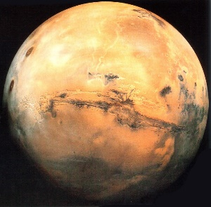

THE ARESIAN
March 2024
Volume 2 No. 3

Editor: Owen Louis David Assistant Editor: Mary Khan Contributors: Peter Roberts, and Mario Pinto. Published by Mars Futures Forum

STARSHIP 3 LAUNCH – THE GIANT LEAP FORWARD!
The third full-scale launch of
Starship 3 (aka IFT 3)
represented a giant leap forward for Space X’s Mars Mission. This was a near orbital mission that successfully got a Starship into an orbital entry (however that was not the mission target). READ MORE about this historic test flight on Page 2
The Aresian makes Mars accessible.

WHAT LIES BEYOND…
Beginning on page 2 we have an article that breaks down the key steps that Space X needs to take before it can send a Mission to Mars.
Find out about the 10 Key Steps.
DESIGN IS NOT JUST ABOUT ROCKETS
If you think that establishing a human settlement on Mars is all about design of rocket, rovers and robots, think again! Interior design will be equally important if the settlement is going to be a success. See Page 5 for details!
THE STARSHIP STORY – LATEST INSTALLMENT
By the Editorial Team
Where are we at after IFT 3?
The Starship 3 launch (also known as the IFT, or Integrated Flight Test, 3) was another huge step forward for Space X and the Starship programme. There had been some talk previously that this would be an orbital test flight but, in the event, the plan was for a near-orbital flight, with the Starship splashing down in the Indian Ocean towards Australia.
With this flight test we saw a flawless launch, perfect separation of first and second stage and excellent ascent of the Starship into an orbital entry path. The problems began with latter part of the flights, as the Starship prepared to descend. Attitude control of the re-entering Starship seemed to be compromised (likely a result of a new thruster system, which differs from the Falcon 9 system). The craft seemed to be rolling rather than adopting a steady attitude. Towards the end of the coverage we saw many objects flying away from the craft – suspected to be heat-resistant tiles from the nose cone.
So how do we evaluate this test? Remembering all the millions (literally) of things that can go wrong with a flight, IFT 3 must be counted a great success. It is another huge step forward for the Starship programme. IFT 4 may close the loop on the rocket’s development prior to a truly orbital flight.

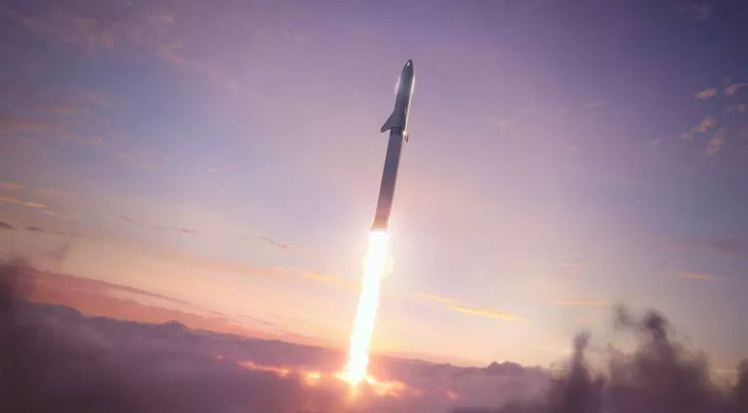
Credit: Space X
Beyond IFT 3… the key milestones.
By Owen Louis David
Mars enthusiasts have reason to think that are living through some of the most exciting moments in human history. With each flight test we seem to be edging towards the Starship going orbital and this offering proof of concept. Let’s assume Space X get the Starship into orbit…what then?
First off, Space X will have to show they have mastered the art of refuelling in orbit,
something which has never been attempted in orbit at this sort of scale. There will have to be perhaps 5 separate Starship launches (which can be undertaken by one or more vehicles), in order to fuel just one Starship in orbit so that they can reach Mars.
Next, Space X will need to develop a human passenger Starship (HPS). This means fitting out the top third of the Starship with everything that humans need for survival and to thrive. So there will be sleeping quarters, hygiene facilities, food prep areas, onboard gym, communal areas and a communications centre. Initially the HPS too will be tested without humans on board, but eventually it will need to be tested for several weeks at least with humans on board. We also need to know that a Starship can cope with the long journey to Mars. So perhaps there will be a couple or more flights over several weeks – probably taking a circumlunar figure of eight path – during which the HPS will be put through its paces and emergency protocols tested.
However, it’s not good enough to know the Starship is good for launch and good for human passengers. Another key step – perhaps the most important – is to determine If the Starship can land safely on Mars (let’s assume it will be able to land safely on Earth in the arms of Mechazilla eventually). There are several issues here. Firstly, we haven’t seen any design from Space X for a Mars or lunar lander version of the Starship. Most people assume it will have landing legs – most obviously a tripod formation for stability. However, let’s not forget that the Mars Starship will be landing on a faraway planet that has many different sorts of surfaces – ice, dust, dunes, rocky terrain to name a few. A tripod arrangement may seem obvious easily said of course but not so easily done for a craft of that size landing on maybe boulder-strewn ground.
Of course, Space X are, very sensibly, planning to land cargo Starships before the human craft follow some 2 years later. This at least ensures ground control will have a good idea of prevailing conditions in the landing zone when it comes time for the human passenger Starships to land. Cameras on the Starships could give a good indication of conditions. Even more helpful might be robot rovers could be deployed from the cargo Starships to undertake a really close inspection of the landing area. They might even be able to lay down heavy landing heat resistant “mats” for the tripod pads. Making sure the mats stay in place would be a major challenge in itself.
Talking of human passenger Starships, another major task for Space X to undertake is the internal configuration of such craft. providing sleeping areas, hygiene facilities, kitchen, food storage, room for socialising/meetings and comms (as well as some essential cargo) .
Of course, the human passenger Starships especially will require their own energy generation system. This will almost certainly be solar power and there have been images published of Starships with solar power fins, presumably deployed after launch. But, again, any such systems, being of such crucial importance to the mission will need to be subjected to extensive testing.
(…continued on Page 4)
There is also the question of what will be the energy generation system on Mars? This will be another key consideration. Solar arrays have been well tested in space as well as on Mars and we can be confident that a working solution will be found. But this will be the first time that solar power on this sort of scale (maybe 40,000 sq. metres of solar array) will have been required on a mission.
Another vital component of the mission will be the rovers. These will include probably two human passenger rovers and a number of robot rovers, the latter being engaged in water ice mining. These rovers will need to be very robust and dependable (since if they fail in mining of ice, then there can be no propellant production for the return journey). Mining of water ice on Mars will be vital to the Mission as the basis for propellant production. So, this is something the crew will have to master. Fortunately, NASA have done a lot of work on a human passenger rover for off-planet exploration. Space X might well buy into that programme. However, as far as I am aware, little or no advanced work has been done on the design of water ice mining robots on Mars.
Propellant manufacture will be absolutely crucial to the success of Mission One. OK, so the crew will have to be familiarsed with every aspect of setting up the facility and keeping it going in the inhospitable environment that is Mars. Of course, it’s one thing to manufacture propellant. It’s another to store it and then refuel the Spaceship tanks with it. There will also be a need transport of fuel to the launch area. There will be a huge amount of design work involved in getting everything in place for the refuelling operation.
Another key element will of course be the production of habs that can be set up on the Mars surface, to form the Base (Alpha Base as Space X call it). Bigelow developed a successful inflatable hab for space that has worked well, being attached to the ISS for several years. Something like that could be the basis for a human-accommodation hab. However, there may be other solutions. The Starship might carry steel parts that could be bolted together to create cylindrical living quarters. The cylinder hab could be covered in regolith for enhanced radiation protection. Of course, there might be more than one hab. We might need habs for propellant production, and habs for the rovers to be garaged in overnight as well.
Another key element in successful Mission prep is of course crew training. It is sometimes overlooked that this will take several years – a five year programme would probably be a reasonable timeline. Space X will need to select a Mission 1 squad (perhaps 20 people) who will then undergo the training. Supposing that leaves 15 people still in the programme after 5 years, they can then select the final 10 who will be the first Pioneers to establish a human presence on Mars.
Another key requirement that tends to get overlooked is the communications system. Space X will have to ensure they have everything in place for effective
(…continued on Page 5)

communications between the Starships and Earth and between the Base and Earth. Many observers were very impressed by the performance of the Starlink satellite communications system which operated well even in a forming plasma cloud during the IFT 3. Starlink might possible be an alternative to the big receiver dishes on Earth. If not, Space X may have to go begging to NASA for access to its communications system. Whatever, this is not something that can be skipped.
So here’s the ten-point checklist of next steps:

- Demonstrating orbital refuelling of a Starship.

- Development of a Human Passenger Starship, fully fitted out for a transit to Mars.

- Extensive long-range testing of the starship, probably with circumlunar flights.

- Creating a Mars/Lunar lander version of the Starship.

- Developing robust human passenger and robot rovers, particularly with a view to supporting the water ice mining operation.

- Manufacturing energy generation systems for both the starship and the Base.

- Developing suitable habs for the Base.

- Putting in place crew training.

- Developing effective communication systems between the Starship and Earth, as well as between the Base and Earth.

- Designing and testing a propellant production facility, together with a means of refilling the return Starship.

Space X need to tick off all those boxes before they can say they are ready for the Mission but if anyone can do it, then I think it is them.
______________

INTERIOR DESIGN
ON MARS –
IT REALLY MATTERS

By Mario Pinto

OK, let’s assume we get to Mars. Can technology deliver all we need? I don’t think so. Humanity does not live by bread alone, as someone once said. Same goes for life support. Life support might keep you alive but it doesn’t deliver the good life.
To live well means to be able to relate in a positive manner with your surroundings, in a way that nourishes your mind and body, your sense of self.
The first thing we have to appreciate is that humans are an evolved species like any other. We evolved in particular sorts of environments, firstly out on the Savannah of Africa. For one thing, we certainly weren’t in an environment where we were assailed by a range of toxic
(…continued on Page 6)

chemicals. Our immune systems of course had to combat a range of often deadly pathogens, but we weren’t subject to the modern toxic environment.
So the first thing I would say about interior design on Mars is that we should not be adding to any toxic loads. A community who will not be able to simply step outside for a breath of fresh air, will need fresh air indoors. We need firstly to ensure that the air supply is indeed delivering the freshest possible air and perhaps we can create artificial breezes in places so we are reminded of the wind on our face.
I would strongly recommend we use natural building materials such as clay (bricks), wood, bamboo and stone (particularly basalt and marble). We should avoid plastics.
Lighting should of course be in the natural spectrum. Then we need plenty of trees and shrubs growing within the within
I want to see plenty of sculptures and statues plenty of art hanging from walls, plenty of natural fabrics, coloured and patterned – works of art in themselves.
On Mars interior design will merge into landscaping and public place design. Personally, I would favour brick paving for walkways and and natural grassed areas within the public spaces. Finishings should be in natural materials such as wood.
Marbles and other igneous rocks such as basalt can be used to face walls. They can create a very elegant effect. They might work well with water features in some places, with light bouncing off the water and dancing on the walls.
Glass is a good, essentially natural material which of course can be used in lots of contexts, from offering views of the landscapes of Mars to coffee tables, doors and so on.
We can grow trees as well as any other plant on Mars. Some species grow much faster than others. It’s interesting to note that recent trials undertaken by Forestry and Land Scotland (FLS) in partnership with precision indoor growing technology specialist, Intelligent Growth Solutions (IGS) have shown that trees can be grown six times faster in vertical farms, compared with out in the open. It is not impossible that the faster growth rate will be shown to last beyond the sapling stage given that vertical farms can deliver optimal growth conditions throughout the life of a tree.
So I would hope that Mars will move into forestry in a big way and use timber for a wide range of applications. We may find a section of the urban complex on Mars given over to a vertical farm that looks not dissimilar to Kew Gardens in some respects.
Interior parks will be very important in establishing a natural feel to the living environment. These might be centred below a glass dome which allows natural light in. In the UK we are not so used to the idea of small urban parks – we benefit in places like London from large green spaces (London is probably the greenest megacity in the world). However, on
(…continued on Page 7)
Mars these small urban parks will be very important. They should incorporate trees, grassed areas, rockeries, planted areas and water features. How much we can do with fauna, as opposed to flora , remains to be seen but it would be nice if we could incorporate butterflies at least into a simple ecosystem.
There will of course be a wide range of retail outlets and restaurants on Mars that will be pleasant places to shop and eat and which will engage our attention. However, another aspect of interior design on Mars is that I feel we would want to incorporate interesting non-commercial spaces into the public environment. In the absence of accessible “outside”, art must stand in place. So we may have walkways that lead us through what are in effect galleries with stimulating visual art or light shows. Perhaps some walkways will offer us huge screen displays. Who knows? The point is that a walk through the public spaces of Mars should involve opportunities to explore new phenomena.
Mars will need its sizeable stadia for sports events and major music, cinema and other arts events. It will need its more formal galleries. But I would like to see it have its smaller meeting place where perhaps people can meet to hear arguments being made, to discuss fundamental ideas, much like the fora of Athens and elsewhere in the ancient world. So we might imagine that at intervals there will be mini-amphitheaters where such debates and performances can take place.
The aim has to be to use the best principles of interior design, public space planning to make of the Mars urban interior something really special that offers people new and interesting experiences every day. Of course people will be able to explore outside but we need to recognise that for most people Mars will be experienced principally indoors, or as view from an interior.
________________
THE LATEST WEATHER ON MARS

Here’s your update for the weather on Mars provided by the Curiosity Rover in Gale Crater.

For the nearest Sol to 25 March 2024 we have a high of -2 degrees Celsius (28 degrees Farenheit), a bit colder than last month, and a chilly low of minus 65 Celsius (or minus 85 degrees Farenheit), though that’s slightly up on last time.
Checking current world temperatures at the time of writing, Edmonton, Alberta in California is -2 Celsius (and it’s supposed to be Spring!).
The weather on Mars is undoubtedly challenging but sometimes it seems people want to talk up the risks and technical challenges rather than observing how often temperatures overlap with the colder parts of Earth.
The Aresian makes sense of Mars.
Tell your friends
about us!

PICK OF THE PICS
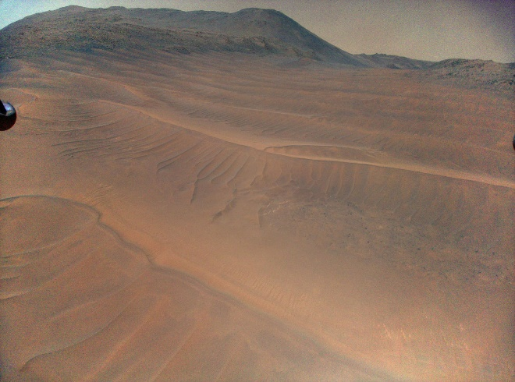
Credit:NASA
Here’s a great pic taken by NASA’s little Ingenuity Mars Helicopter during its 70th flight, on Dec. 22, 2023 featuring dunes and sand ripples. The Helicopter is the first Earth-launched craft to fly over Mars using atmospheric lift. It was shot from about 12 meters above the surface. The image shows the widest area of sandy, relatively featureless terrain the helicopter had ever observed over up to that point.
Ingenuity has certainly given us some lovely views of Mars taken at height. Sadly it suffered what might well have been a fatal crash landing at the conclusion of Flight 72, on Jan. 18, 2024. The cause is likely to have been an onboard navigation failure due to its inability to land in what turned out to be very featureless terrain.
LET US KNOW WHAT YOUR FAVOURITE PIC IS AND WHY! WE ARE ALWAYS INTERESTED IN YOUR COMMENTS.
PULSAR FUSION – COMING REVOLUTION IN MARS TRANSIT
Here at The Aresian we are keeping tabs on Pulsar Fusion, the UK-based company who have plans to create a super-fast rocket that will use nuclear fusion to accelerate a craft to 100s of thousands of miles per hour.
It has been reported that Pulsar Fusion have already begun construction of an 8 metre fusion chamber that they hope to have in action by 2027. The chamber will eventually be capable of accelerating spacecraft to something like 500,000 MPH, which would dramatically reduce Mars transit times.
The Chamber is being built in Bletchley (part of Milton Keynes, in Buckinghamshire).
We have seen various estimates of how short the journey time to Mars could be with this technology (known as Direct Fusion Drive) – even as low as 12 days. That would, of course, be an absolute game-changer. It might come at just the right time for an expanding human settlement on Mars.
You can find out more about the company’s proposals at the following link.
https://pulsarfusion.com/products-development/fusion-propulsion/

